Dashboard Design

Date | 10 Dec 2025
Team ID | SWUID20250222796
Project Name | Predicting Plant Growth-Stages with Environmental and Management Data Using Power BI
Maximum Marks | 5 Marks

Creating an effective dashboard involves thoughtful design to ensure that the presented information is clear, relevant, and easily understandable for the intended audience. Here are some key principleand best practices for dashboard design

Activity 1: Interactive and visually appealing dashboards
Creating effective dashboard involves thoughtful design to ensure that the presented information is clear, relevant, and easily understandable for the intended audience. Here are some key principles and best practices for dashboard design:
Clear and Intuitive Layout
Use Appropriate Visualizations
Colour and Theming
Interactive Filters and Slicers
Drill-Down Capabilities
Responsive Design
Custom Visuals and Icons
Use of Infographics
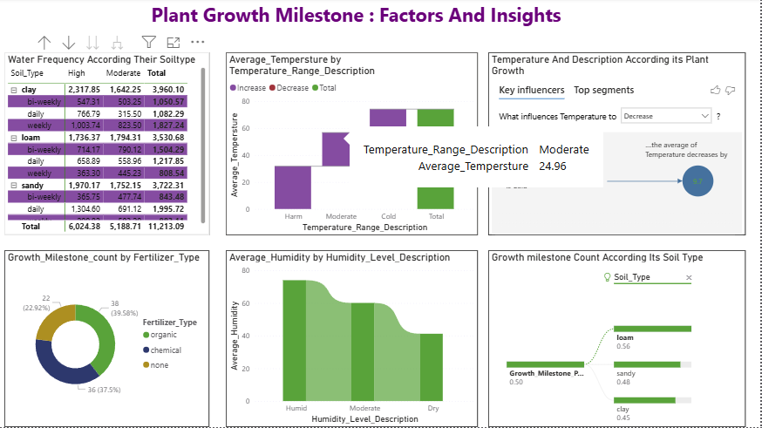
- Here are five potential outcomes from the dashboard image provided ("PLANT GROWTH MILESTONE: FACTORS AND INSIGHTS"):

- Soil Type/Watering Optimization Insight: The highest total growth count is achieved by the combination of Sandy soil with a weekly watering schedule (3,722.31), which is significantly higher than bi-weekly watering in the same soil (1,970.17).

- Environmental Influence on Temperature: The analysis shows that when the Temperature_level_description is Cold, the average temperature decreases by 9.7 (as seen in the Key Influencers visual), providing a clear quantifiable link between the categorical description and the numerical impact.

- Fertilizer Efficacy: Chemical Fertilizer is the dominant factor in achieving growth milestones, accounting for 39.58% of the total count (38 milestones), followed closely by the use of Organic Fertilizer at 36.75% (36 milestones).

- Humidity Segmentation: The average humidity when categorized as Humid is 74.02, which is a significant -18.8% change compared to the average humidity when categorized as Moderate (60.10), clearly segmenting the environmental data.

- Soil Type Contribution: Loam soil has the highest overall contribution to growth milestones (35 milestones), closely followed by Sandy soil (31 milestones), suggesting Loam is the most productive soil base for this specific plant.

